**INGLÊS III – BANCO DE DADOS**

Class Didactic Material

Profa. Teresinha de Fátima Nogueira

# Warm up: song: Elton John & Dua Lipa - Cold Heart - PNAU Remix - <https://www.youtube.com/watch?v=sm_XpTTtRKk>

**Class 1 - Content: Professional skills**

I – Objective: Talking about professional skills

Problem 1: At job interviews it is common that interviewers ask you to talk about your professional skills. So, to practice this sort of situation, prepare a presentation talking about your professional skills (4 skills). (2,0 pontos)

To help you to solve the problem, you can do the following activities or choose your own way:

1 – Watching a video: Watch this video about the top soft skills needed in the workplace and take notices about your 6 best skills.

<https://www.youtube.com/watch?v=t0mI-52eX58>

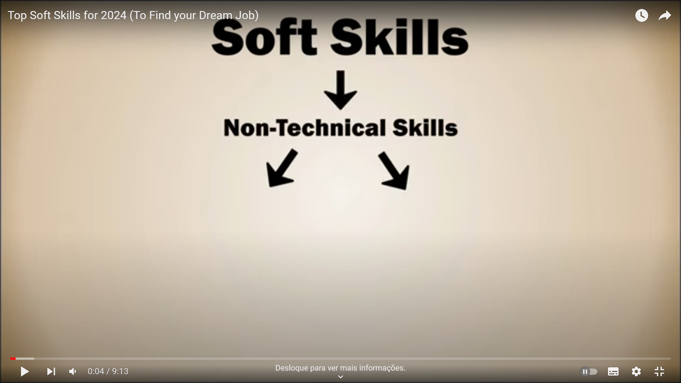

**____________________________________________________________________________________________________________________________________________________________________________________________________________________________________________________________________________________________________________________________________________________________________________________________________________________________________________________________________________________________________________________________________________________________________________________________________________________________________________________________________________________________________________________________**

**Class 2 - Content: Professional skills**

I – Objective: Talking about professional skills

# Warm up: song: Rihanna ft. JAY-Z - Umbrella - <https://www.youtube.com/watch?v=hU7yrMWQFB8>

2 - Speaking - Make and answer the following questions:



(<https://www.freepik.com/free-photos-vectors/people-talking>)

1 -Do you prefer written or verbal communication? Why?

Verbal communication because for me is easyer to the expresses my ideas

2 – Which one is more important to you and why: to be a good listener or a good communicator?

Good Listener because it’s natural for me

3 – Use up to 5 sentences to sell me your mobile phone.

a - My Mobile Phone has 128gb of hard memory.

b – He has 12mp of camera and capture nice pictures.

c - he has a good screen with an excellent quality

d – it has a color black

e – and I sell it to you for just R$ 1.200,00

4 – Which one do you prefer and why: team work or working alone?

Team work because I learning more with they

5 – Your teammates are all in agreement on how to approach a task but you disagree. How do you react?

I try to adapt to the idea and deliver my best

6 – How would you deal with a teammate who wasn’t doing his/her share of work?

I talk to him to try to understand what is happening

7 – You know your manager is 100% wrong about something. What do you do?

I try to explain that his idea would not be the best solution

8 – What do you expect from a manager?

That he has empathy, good communication and personality

9 – Give me an example of when you’ve successfully solved a problem.

I needed to create communication between a form and the server

10 – Give an example of a time when you’ve had to be creative in solving a problem.  
I needed to create a graph to present data instead of showing it in a list

11 – What are the key ingredients to building good relationships with others?

Be sincere, honest and have character SINCER / QUÈRETER

12 – How do you deal with situations where there is tension between you and a colleague?

I try to talk to him to understand the conflict and reach a consensus

13 – How do you prioritize your work if you have a great number of important deadlines?

I check which work is most important to start with.

14 – What are the most important ethics in the workplace?

Honesty and transparency

15 – How do you stay motivated when working on a project that doesn’t interest you?

Look on the positive side I'm going to learn something new

16 – What do you do if you realize you’ve made a bad or wrong decision?

Seeing that the result went in a different direction than expected

(adapted from <https://toggl.com/blog/100-soft-skills-questions-to-help-you-hire-top-talent>)

**Class 3 - Content: Professional skills**

I – Objective: Talking about professional skills

3 – Speaking – prepare the oral presentation about your professional skills (four) suggested in problem 1.

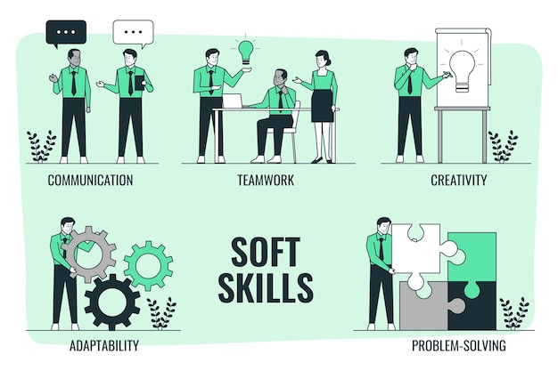

(from <https://www.freepik.com/free-vector/soft-skills-concept-illustration_24488084.htm>)

**Class 4 - Content: Professional skills**

I – Objective: Talking about professional skills.

4 – Oral presentation: Oral presentation of the activity suggested in problem 1. (2,0 pontos)



(from <https://www.istockphoto.com/br/foto>)